

Providing Scholarships for Young Ladies in Prince William County

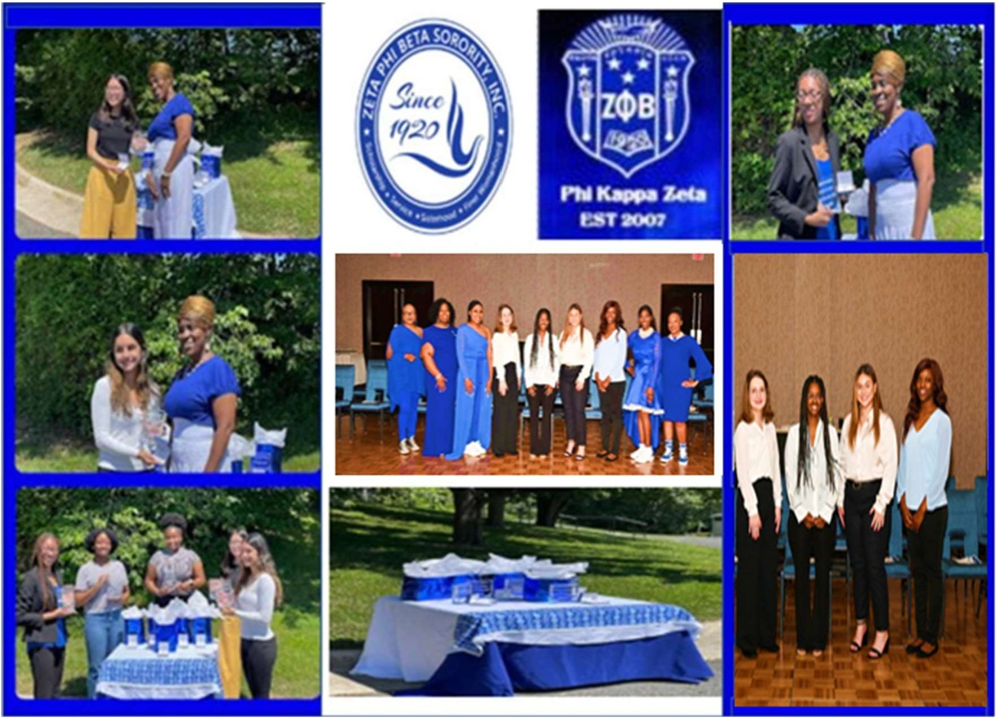

1 | P a g e
Scholarship Application Packet School Year 2025-2026

History of Zeta Phi Beta Sorority, Incorporated and Phi Kappa Zeta Chapter Zeta Phi Beta Sorority Incorporated, was founded January 16, 1920, on the campus of
Howard University in Washington, D.C. The sorority’s principles are Scholarship, Service, Sisterhood, and Finer Womanhood. Phi Kappa Zeta Chapter (PKZ) was chartered December 5, 2007, in Woodbridge, VA. PKZ’s programs primarily focus on community service, which supports literacy, national initiatives, and helping other people excel.

The Phi Kappa Zeta Scholarship Program
The Phi Kappa Zeta Scholarship Program was established in January 2008. Applicants must meet the following Eligibility Requirements: enrolled in Colgan High School or any other Public High School in Dumfries or Woodbridge, VA; female high school senior; minimum GPA of 2.75 (on a 4.0 scale).
*Each Scholarship Candidate MUST participate in an interview- February 28, 2026.

Calendar
The application period is November 1, 2025 through January 30, 2026. Packets can be mailed to Phi Kappa Zeta Attention: Scholarship Committee, PO BOX 6369, Woodbridge, VA 22195. All packets mailed must be postmarked no later than January 30, 2026. Packets may also be submitted electronically to: https://tinyurl.com/PKZ25-26Scholarship. Packets may NOT be submitted using a combination of mail and electronic submission. Each applicant must choose one option to submit their complete packet. Packets will NOT be accepted after January 30, 2026. Incomplete and late packets will NOT be considered. Award determinations will be finalized by March 13, 2026 and successful applicants will be notified by that date.

Responsibilities and Expectations
Scholarship candidates are required to participate in an interview to be held by the Phi Kappa Zeta Scholarship Committee, Saturday, February 28, 2026. Each candidate invited to the interview will be notified via email prior to this date, to include specific interview instructions. Please adhere to all deadlines and administrative requirements.

Thank you for your interest in our Scholarship Program. If you have any questions, please feel free to contact the Scholarship Committee via email: scholarshippkz@gmail.com . Please include your name, phone number, and email information so that we may respond to your inquiry.

Eligible/Criteria
- Available to current female high school seniors pursuing a full-time degree from a two- or four- year accredited college or University, with a GPA of 2.75 or higher. Academic progress must be documented by an official transcript, or letter of recommendation from a counselor within the school of attendance.
- Applicants must show admirable leadership experience within their school and/or community setting. Applicants must submit a letter of at least 20 community service hours from the organization(s) that provided the service opportunity or administrator from high school of attendance. Applicants must also submit two letters of recommendation.

- Award will be given to the accredited college or university, upon proof of enrollment provided by the awardee/ Institution prior to June 20, 2026, if proof of enrollment is not received by this date there will be a delay in funding until August 2026. If the awardee does not attend a two- or four-year accredited college or University, the scholarship funds will be given to the next recipient upon verification of enrollment or divided among current award recipients. This is at the discretion of the Scholarship committee.

Participant Essay

Please respond to the following question: “What are social media's positive and negative influences impacting young women?”
A 500-750 word essay response typed on a separate sheet of paper, double-spaced, Times New Roman or Arial font (size 12) is required. Please ensure applicant’s name AND signature is on the essay. Parent/Guardian Initial that you have read and understand this requirement:

Grade Verification

Applicant must have their school counselor submit her OFFICIAL transcript to: https://tinyurl.com/PKZ25-26ScholarshipTranscript. The minimum overall Grade Point Average (GPA) requirement for participation in the Phi Kappa Zeta Scholarship Program is 2.75 (on a 4.0 scale).

Parent/Guardian Initial that you have read and understand this requirement:

Community Service Verification

Applicant must submit verification of active involvement in community service by submitting at least 20 community service hours electronically with this application. Acceptable verification consists of a form or letter from the organization(s) that provided the service opportunity and administrator from high school of attendance. Please submit the form or letter with this application.

Parent/Guardian Initial that you have read and understand this requirement:

Recommendation Letters

Applicant must submit two letters of recommendation with this application. The reference should submit the letter on the applicant’s behalf to: https://tinyurl.com/PKZ25-26LOR. Reference letters must be typed, and not handwritten, must come from an academic or professional resource, and must include – at a minimum – the following:

- Relationship to applicant
- Character and integrity of applicant
- Applicant contribution to school or community

Parent/Guardian Initial that you have read and understand this requirement:
Certification

I hereby certify that:
  - All information submitted in the application is true and correct. I give the Phi Kappa Zeta Chapter permission to verify any information contained in this package.
  - I am a student planning to enroll in a two- or four-year college or university degree program.
  - Funds received from Phi Kappa Zeta will be used solely for the purpose of paying for educational expenses.
  - I understand the College Verification Form must be completed and returned to the Phi Kappa Zeta Chapter prior to funds being disbursed. I also understand that funds will be sent directly to the college on my behalf unless otherwise stated by the Phi Kappa Zeta Scholarship Committee.
  - I will notify the Phi Kappa Zeta Chapter immediately in writing if there should be any change or interruption in my plans to enroll in college or university degree program.

Applicant Signature: Date:
Email: Phone Number:

Parent/Guardian Signature: Date:
Email: Phone Number:

Permission/Release

I hereby grant permission to use my name, comments, pictures, or photography for public relations, advertising, or any other lawful purposes, and I waive any right to inspect or approve the finished version(s) including written copy that may be created in conjunction therewith. I understand that information from my official transcript(s), scholarship application, and submitted essay may be used.

Applicant Signature: Date:

Parent/Guardian Signature: Date:

APPLICATION PACKET CHECKLIST
(Note: The form MUST be included with your application packet)

Application Requirement | Applicant Only Circle Y or N |  | Scholarship Panel Only Circle Y or N
Completed Essay (please see Participant Essay, pg.3 for detailed requirements) | Y | N | Y | N
OFFICIAL Transcript (please see Grade Verification pg.3 for detailed requirements) | Y | N | Y | N
Community Service Verification (please see Community Service Verification, pg.3 for detailed requirements) | Y | N | Y | N
Two Reference Letters (please see Reference Letters, pg.3 for detailed requirements) | Y | N | Y | N
Completed Application (All requirements listed above, are Verified and in the packet) | Y | N | Y | N

Applicant Signature: Date:

Name of School Counselor:

Scholarship Chair Signature: Date:

