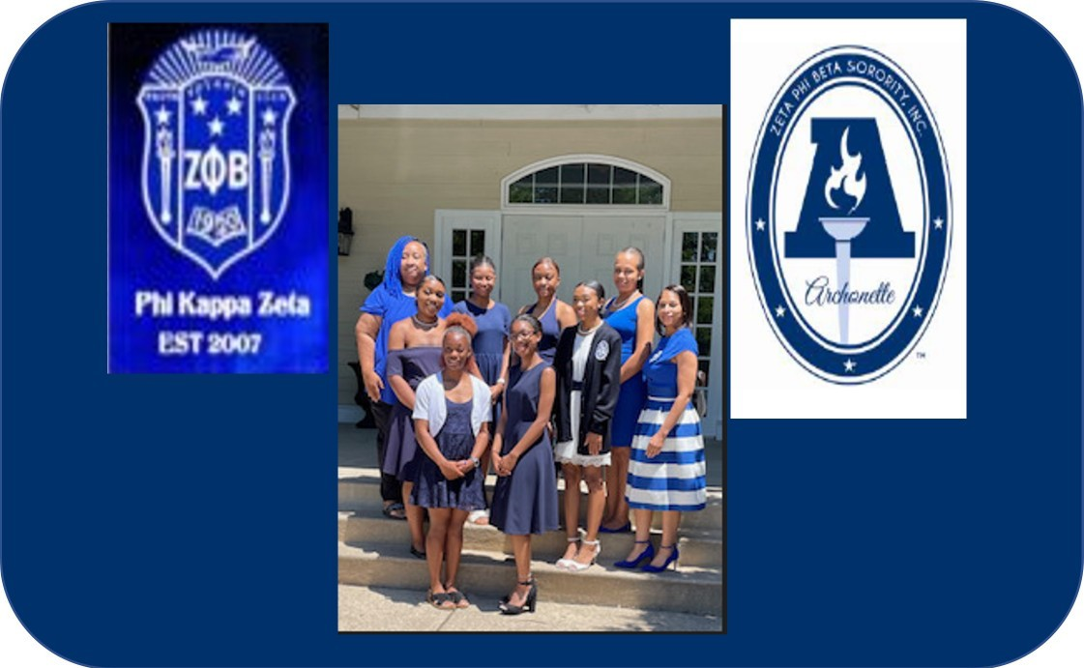

*Bettye Grayson Scholarship*

*Providing Scholarships & Development Programs for*

***Phi Kappa Zeta Archonette Seniors***

**Bettye Grayson Scholarship Application Packet School Year 2024-2025**

[**http://phikappazeta1920.org/initiatives/scholarship-fund/**](http://phikappazeta1920.org/initiatives/scholarship-fund/)

# History of Zeta Phi Beta Sorority, Incorporated and Phi Kappa Zeta Chapter

Zeta Phi Beta Sorority Incorporated was founded January 16, 1920, on the campus of Howard University in Washington, D.C. The sorority’s principles are Scholarship, Service, Sisterhood, and Finer Womanhood. Phi Kappa Zeta Chapter (PKZ) was chartered December 5, 2007, in Woodbridge, VA. PKZ’s programs primarily focus on community service, which supports literacy, national initiatives, and helping other people excel.

# The Phi Kappa Zeta Scholarship Program

The Phi Kappa Zeta Scholarship Program was established in January 2008, and an additional Archonette Scholarship named in honor of PKZ’s first member with over fifty years of service to the sorority, Bettye Grayson, was established in October 2022.

# Bettye Grayson Scholarship

The Archonette Youth Affiliate is comprised of young ladies between the ages of 14-18 years of age attending high school, who show interest in learning and exhibiting the principles of Zeta Phi Beta Sorority, Incorporated. Zeta Phi Beta Sorority, Incorporated, Phi Kappa Zeta of Woodbridge, VA will annually provide financial assistance to a Phi Kappa Zeta Archonette high school senior. The Archonette must be pursuing higher education at a two or four year accredited college or university. All scholarships will be paid to the college or university on the student’s behalf. If the student receives a full scholarship that covers tuition as well as room and board from the college or university, the student will notify the scholarship committee and provide documentation. In this case scholarship funds awarded will be given to the next recipient, upon verification of enrollment. Award to the next recipient is at the discretion of the Scholarship committee.

Eligible/Criteria

* Available to current high school seniors pursuing a full-time degree from a two- or four- year accredited college or university, with a GPA of 2.75 or higher. Academic progress must be documented by an official transcript, or letter of recommendation from a counselor within the school of attendance.
* Applicants must show admirable leadership experience within their school and/or community setting. Applicants must submit a letter of at least 20 community service hours from the school of attendance, the organization in which the Community Service was served, or their Zeta Phi Beta Sorority, Incorporated youth advisor. The Archonette must provide a letter of recommendation their Zeta Phi Beta Sorority, Incorporated Youth advisor as well as one additional letter of recommendation from a school counselor, teacher, or community service supervisor.
* Award will be given to the accredited college or university, upon proof of enrollment provided by the Archonette/Institution prior to June 20, 2025, if proof of enrollment is not received by this date there may be a delay in funding until August 2025. If the Archonette does not attend a two- or four-year accredited college or university, the scholarship funds will be given to the next recipient upon verification of enrollment at the discretion of the Scholarship committee.
* The Archonette can only be awarded one Phi Kappa Zeta Scholarship in the year of application, i.e., Bettye Grayson or PKZ High School Scholarship.

# * Each Scholarship Candidate MUST participate in an interview- February 8, 2025

**Calendar**

The application period is November 25, 2024 through January 24, 2025. Packets can be submitted electronically to: https://docs.google.com/forms/d/1EqAfvZZeIWFcPsU9p6iMCVygRPu3ZIB0udGwfqq- Ra4/edit?ts=659b4895 or mailed to P.O. Box 6369, Woodbridge, VA 22195. If electronic submission, all transcripts and letters of recommendation MUST be mailed to the above address and postmarked by January 24, 2025. Packets will NOT be accepted after January 24, 2025. Incomplete and late packets will NOT be considered. Award determinations will be finalized by February 28, 2025, and notification letters will be sent out the following week. Successful applicants will be notified separately regarding next steps.

# Responsibilities and Expectations

Scholarship candidates are required to participate in a virtual interview to be held by the Phi Kappa Zeta Scholarship Committee, Saturday, February 8, 2025. Each candidate invited to the interview will be notified via email prior to this date, to include specific interview instructions. Please adhere to all deadlines and administrative requirements. Scholarship award recipients will receive a formal presentation that will take place during their school’s end of year award ceremony.

***Thank you for your interest in our Scholarship Program. If you have any questions, please feel free to contact the Scholarship Committee via email***: [scholarship@phikappazeta1920.org](mailto:scholarship@phikappazeta1920.org) ***.***

***Please include your name, phone number, and email information so that we may respond to your inquiry.***

# Participant Essay

Please respond to the following question: “What are social media's positive and negative influences impacting young women?”

A 500-750-word essay response typed on a separate sheet of paper, double-spaced, Times New Roman or Arial font (size 12) is required. **Please ensure applicant’s name AND signature is on the essay**.

Parent/Guardian Initial that you have read and understand this requirement:

# Grade Verification

Applicant must submit her OFFICIAL transcript in a sealed envelope with this application. The minimum overall Grade Point Average (GPA) requirement for participation in the Phi Kappa Zeta Bettye Grayson Scholarship is 2.75 (on a 4.0 scale).

Parent/Guardian Initial that you have read and understand this requirement:

# Community Service Verification

Applicant must submit verification of active involvement in community service by submitting at least 20 community service hours in a sealed envelope with this application. Acceptable verification consists of a form or letter from the organization(s) that provided the service opportunity or sponsor from the high school of attendance if the service was completed from your school. Please submit the form or letter with this application.

Parent/Guardian Initial that you have read and understand this requirement:

# Recommendation Letters

Applicants must submit two letters of reference with this application, each in sealed envelopes and the reference’s signature on the flap, References must be typed, and not handwritten. One recommendation must come from an academic or professional resource and the second recommendation must come from your Archonette Youth advisor. Each recommendation must include – at a minimum – the following:

* Relationship to applicant
* Character and integrity of applicant
* Applicant contribution to school or community

Parent/Guardian Initial that you have read and understand this requirement:

# Certification

I hereby certify that:

* All information submitted in the application is true and correct. I give the Phi Kappa Zeta Chapter permission to verify any information contained in this package.
* I am an Archonette planning to enroll in a two- or four-year college or university degree program.
* Funds received from Phi Kappa Zeta will be used solely for the purpose of paying for educational expenses.
* I understand the College Verification Form must be completed and returned to the Phi Kappa Zeta Chapter prior to funds being disbursed. I also understand that funds will be sent directly to the college on my behalf unless otherwise stated by the Phi Kappa Zeta Scholarship Committee.
* I will notify the Phi Kappa Zeta Chapter immediately in writing if there should be any change or interruption in my plans to enroll in a college or university degree program.

Applicant Signature: Date:

Email: Phone Number:

Parent/Guardian Signature: Date:

Email: Phone Number:

# Permission/Release

I hereby grant permission to use my name, comments, pictures, or photography for public relations, advertising, or any other lawful purposes, and I waive any right to inspect or approve the finished version(s) including written copy that may be created in conjunction therewith. I understand that information from my official transcript(s), scholarship application, and submitted essay may be used.

Applicant Signature: Date:

Parent/Guardian Signature: Date:

# APPLICATION PACKET CHECKLIST

***(Note: This form MUST be included with your application packet)***

|  |  |  |  |  |
| --- | --- | --- | --- | --- |
| **Application Requirement** | **Applicant Only Circle Y or N** | | **Scholarship Panel Only**  **Circle Y or N** | |
| Completed Essay (please see Participant Essay, pg.3 for detailed requirements) | Y | N | Y | N |
| OFFICIAL Transcript (please see Grade Verification pg.3 for detailed requirements) | Y | N | Y | N |
| Community Service Verification (please see  Community Service Verification, pg.3 for detailed requirements) | Y | N | Y | N |
| Two Reference Letters (please see Reference Letters, pg.4 for detailed requirements) | Y | N | Y | N |
| Completed Application (All requirements listed above, are Verified and in the packet) | Y | N | Y | N |

Applicant Signature: Date:

Name of School Counselor:

Scholarship Chair Signature: Date: